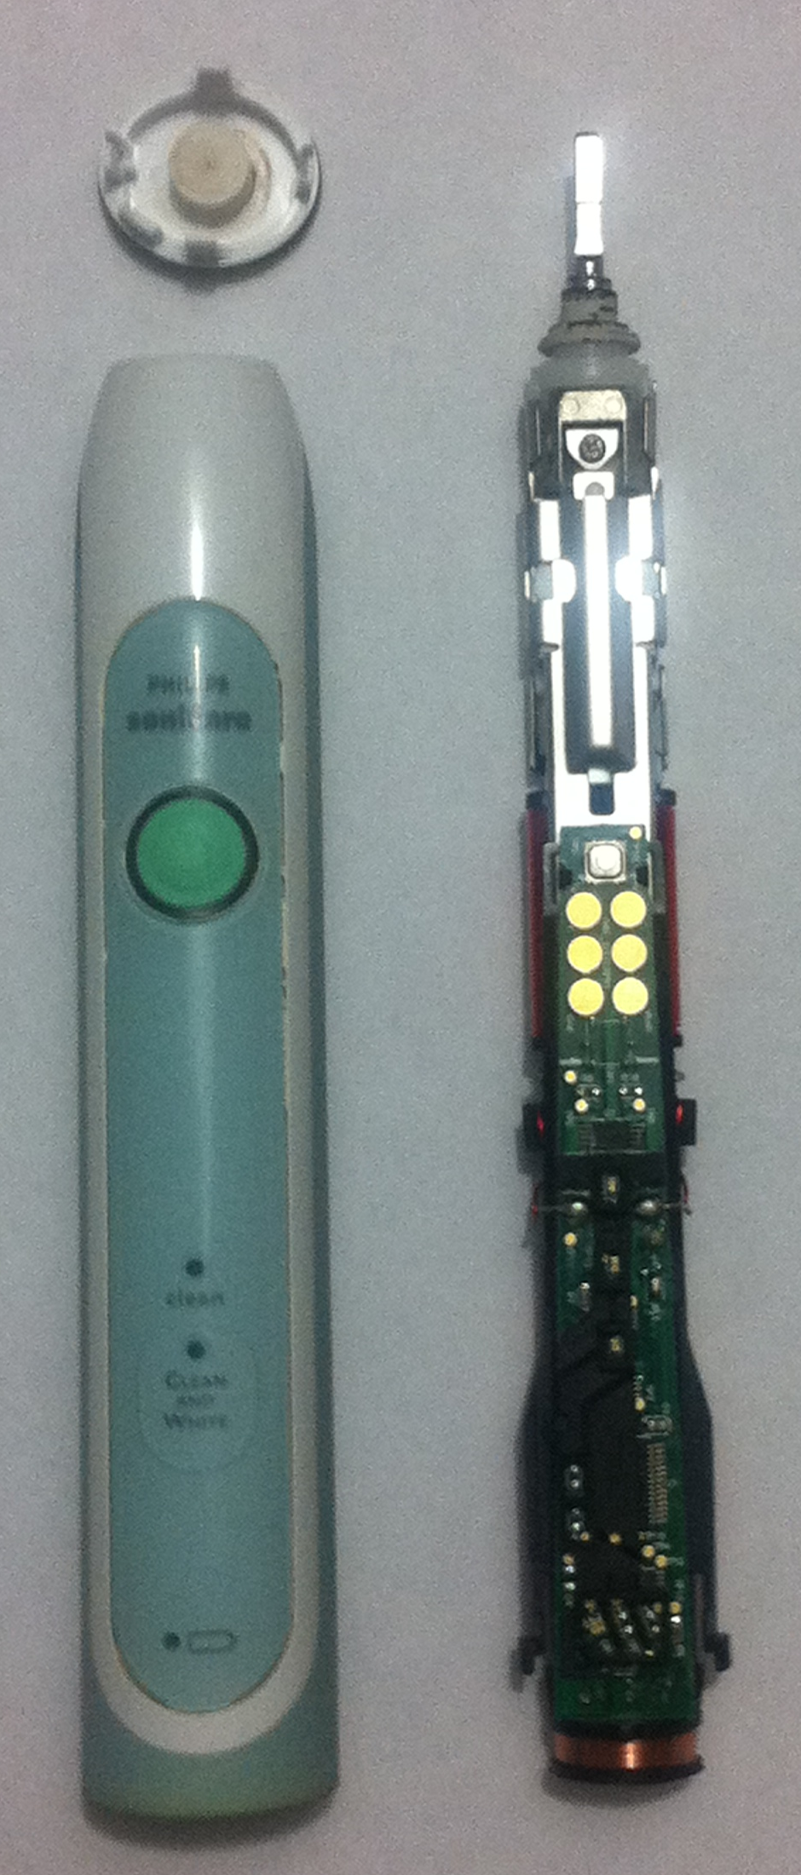
1
2
1: Switch

The same mechanism used to power on and off an automatic brush can be used for a vortexer. On the first push, the switch turns on the toothbrush/vortexer; on the next push, it turns off the toothbrush/vortexter.

2. Circuit board

The circuit board basically monitors the switch and battery so it turns on and off the toothbrush and tells the user how much of battery is left. For some automated toothbrush, it also monitors how many cycles of oscillation/rotation the motor has worked. By doing so, the circuit can monitor how long the toothbrush has been working and notify the user every one or two minutes by repeatedly turning on and off the motor in a brief period of time. The entire circuit board could be implanted to a vortexer without modification.
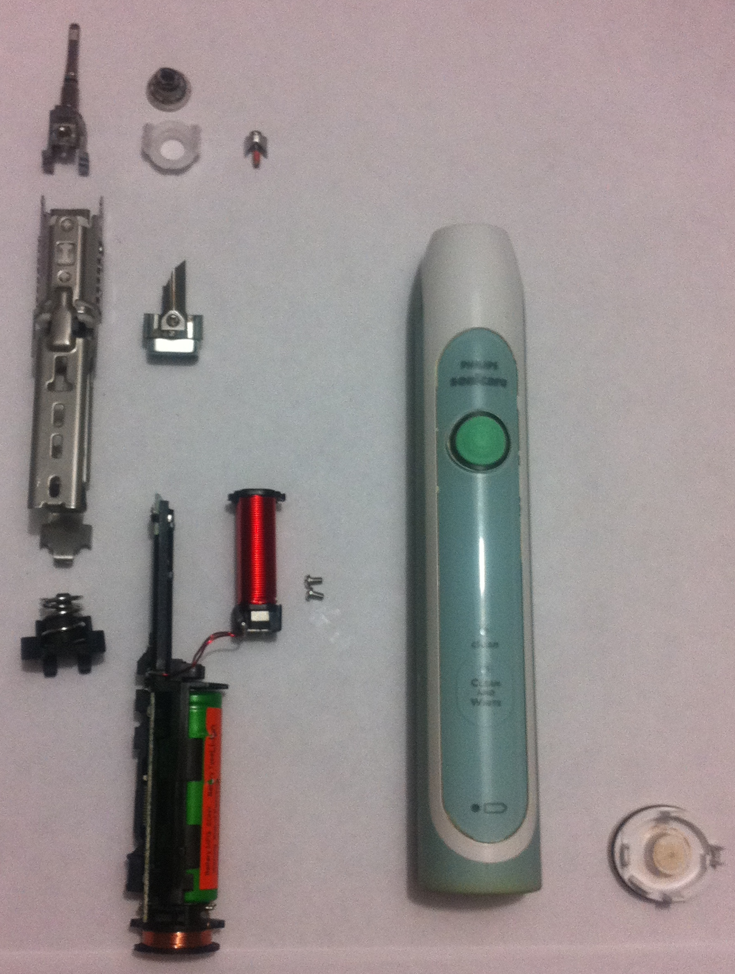
1: Toothbrush head:

The head has to be modified to grab the tube and to open/close the cap. We will work on it once we have a final design of the cap and the tube.

2: Gears

This part of the toothbrush could not be opened to be examined but for most automatic toothbrushes, gears that create both oscillatory and rotator movement. We might want to gear up or down to match the desired vibration rate of the vortexer.

3: Spring

The spring creates the oscillatory movement that allows the toothbrush to move up and down.

4. Rechargeable battery.

Unless we want the device to be running on batteries, we can get rid of this part and simply relocate the circuit board mounted on it.
2
4
1
3
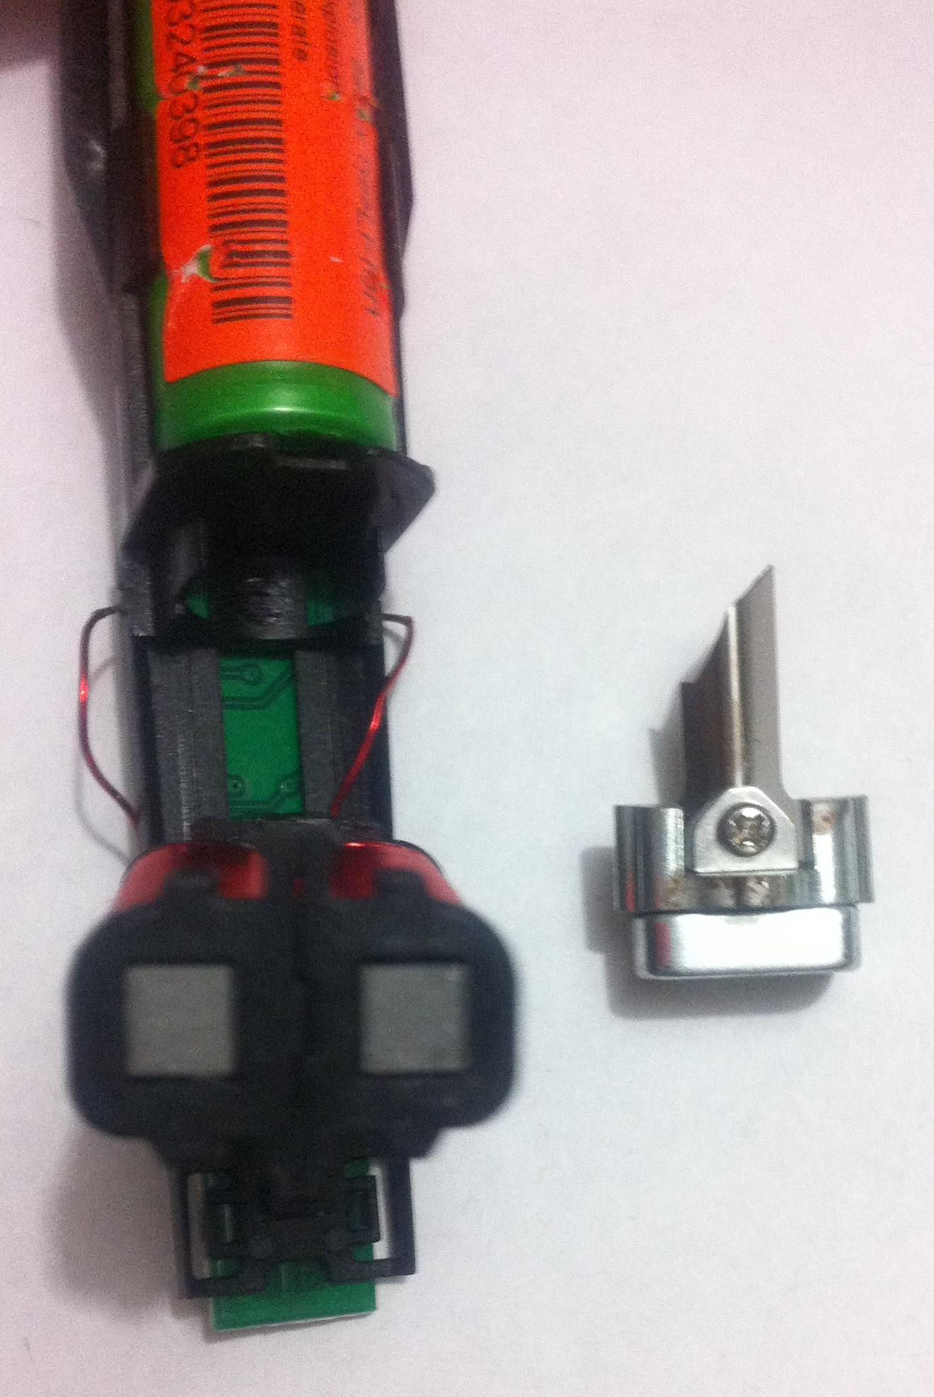
2
1
3
1: Magnetic part - 1

This part has clean cut surface with a very sharp end. It is possible that it was originally designed to look like this but it is also possible that some portion of this original part has been cut away from it, causing the gears to malfunction.

2 & 3: Magnetic parts - 2

Two identical magnetic square pieces are attached separately. These parts along with the magnetic part1 seem to be all working together to create a rotating movement on the toothbrush.

