Julian Alvarez
EID 103
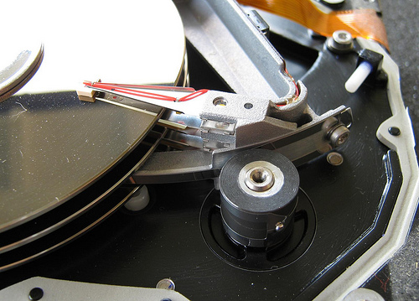
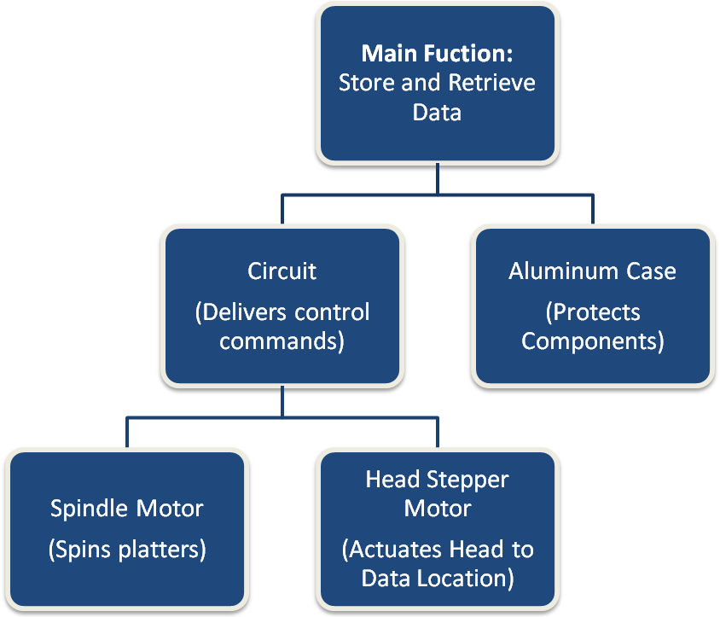
Hard Drive: Functions Breakdown
Stepper Motor
Read / Write Head
Platters
Spindle

