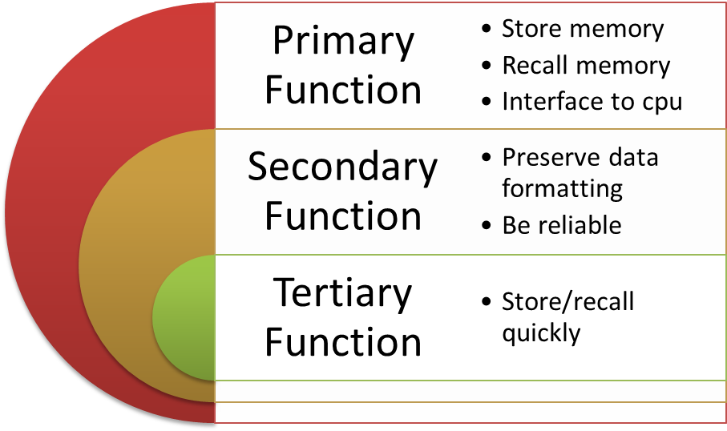
Magnetic Recording
Actuator arm – reading
Stepper motor – spinning magnetic platter’”
Limited by heat, mechanical movement time, stepper motor speed
Formatting – SAS or SATA
Addressing data on the drive
SCSI – standards for transferring data between system and peripheral devices

