MESH BAG

Possible Designs
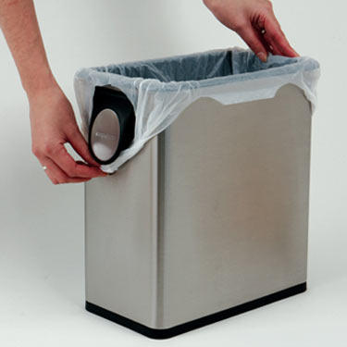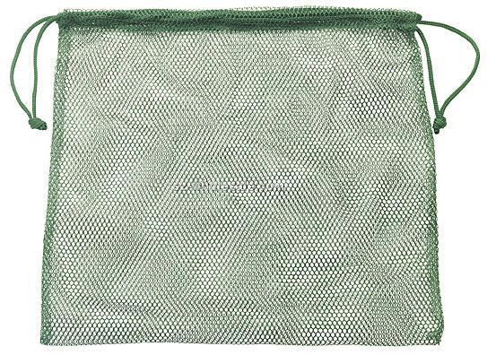
“Trash Bag” “Drawstring”

What It’s Meant To Do | Where It Breaks Down
1. Keep allograft in place in chamber | a) Chamber size already restricts movement  b) If knee is suspended in the bag, it won’t necessarily remain submerged  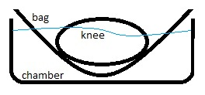  c) If bag is big enough to keep submerged, then it is the same as no bag at all in terms of transplant movement
2. Keep the “junk in the trunk” | No reason why it breaks down… actually performs its purpose
3. Cost effectively implement the above functions while maintaining design integrity | a) Based on researched prices, bags are >> $1/bag  b) “Trash bag” would interfere with media in/out ports  c) Question of how to open/close “drawstring” while simultaneously keeping bag in place  d) Requires use of sonic welding or some other method to attach bags to chamber

